AUGUST UPDATE

BALLSTONE, BALLINGHAM & HENTLAND, DINEDOR, HOLME LACY, LITTLE DEWCHURCH and LOWER BULLINGHAM
DINEDOR HILL WARD
From your local County Councillor
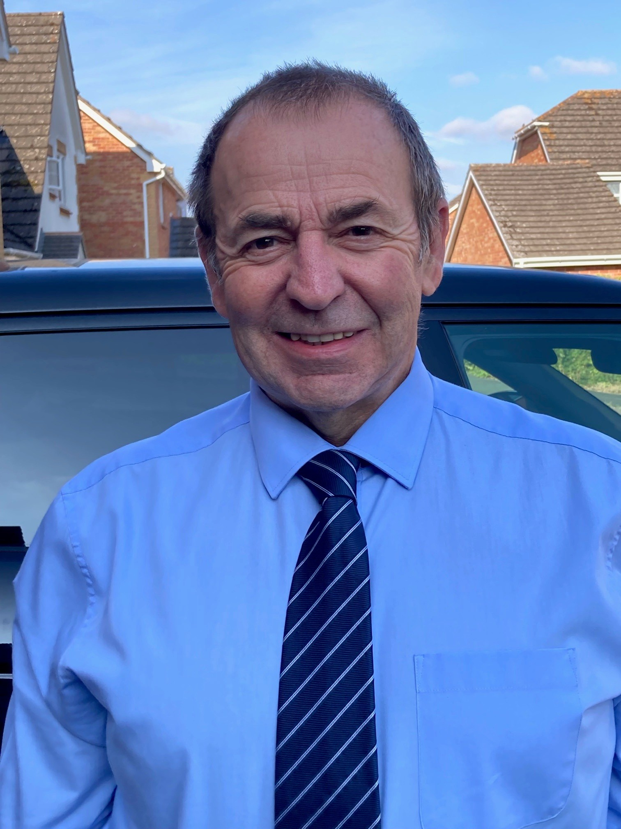
David Davies

david.davies2@herefordshire.gov.uk

Dear Residents

I am pleased to report that the Department for Education has made the decision to end government intervention in Herefordshire children's services and has revoked the statutory direction issued to the council in September 2022 under the previous administration.
This decision follows significant improvements across children's services over the last three years and represents a major milestone in the council`s work to deliver better outcomes for children and young people across Herefordshire. The latest decision builds on the progress recognised by Ofsted, which announced Herefordshire's children's services to be “Good” with “Outstanding leadership” in January this year. This is a significant achievement and tribute to the work of staff, partners and the council’s political leadership.

The exception dry weather is bringing several problems of wild and outdoor fires as we are witnessing in Europe and at home. Just over the Welsh border saw a large fire on Hanter Hill which lasted several days. Several of the Herefordshire fire crews supported the Mid Wales fire authority and played an important roll in protecting a house on the edge of the hill. Our local Fire service has been involved daily with many fires in the open, farm and crop fires thought-out our County.

Please be careful when walking or traveling in our countryside the vegetation is so dry and highly at risk of fire. The dry summer has also seen an early harvest for farmers and with moisture levels so low that the oilseed rape had to be combined from 4am till the heat of the sun forced the moisture too low.

Targeting all farmers and rural communities!
West Mercia Police want to hear the views of our rural communities around how you would like West Mercia Police to communicate with you. This includes farmers and anyone living in a more remote or rural location. If that’s you, please take a few minutes to complete this short survey which will close on Monday 31st August. Copy and paste -- https://survey.neighbourhoodmatters.co.uk/Survey/HASH/FE2A0BCBFEBD9ADBD9930CF973D894AF

In this month’s update I welcome DEFRA`s new report on Rural England, the problem of local fly tipping, tackling homelessness in the county, the latest on Highways plus usual contact lists.

As ever if I can be of any help, please don’t hesitate to contact me.

Stay safe and well

Dave

Fly Tipping is Criminal

The photo shows the disgraceful fly tipping that took place last month. Most probably commercial building waste in this case. Herefordshire Council removes fly tipping waste on council owned property including vergers but not off private and other owners land. Hence this dump was removed quickly by the council out of our council tax.
Fly tipping is a criminal offence with maximum penalty of £50,000 fine and/or 5 years imprisonment.
If you spot someone fly tipping:
- Make a note of any vehicle used, including model, colour and registration number. If it is safe to do so without being seen, take a photograph or video of the activity
- Note the fly tippers' clothes, and distinguishing features. If you can hear the fly tippers, take note of anything which was said along with the speakers' accents
- Make a note of what they dumped, the location, weather conditions and how far away you were at the time
Never touch any waste which has been dumped. It may be hazardous and contain harmful substances, chemicals, glass or needles. Our officers are specially trained and equipped to deal with this waste. There may also be clues which could help identify the perpetrator, so please treat the waste as a crime scene.
Report Fly Tipping https://www.herefordshire.gov.uk/rubbish-and-recycling/report-a-problem/

Championing Rural Communities

The Rural Services Network is chaired by Cllr Roger Phillips (Herefordshire Council Chairman)

The Rural Services Network (RSN) contributed to Defra's Future of Rural England Report, having contributed to the Rural Taskforce which informed the development of the report.
Bringing together government departments and organisations from across the rural sector, the Rural Taskforce was established to identify the opportunities and challenges facing rural communities and businesses, helping to ensure rural considerations are embedded much earlier in policy development.

The RSN recognises the report as an important milestone in strengthening the cross-government approach to rural policy. It welcomes the commitment to establish a new cross-government Rural Board, bringing together senior officials from across Whitehall to oversee rural proofing, alongside the introduction of clearer measures, metrics and annual reporting to strengthen accountability and monitor progress on rural priorities.
These commitments have the potential to improve how rural considerations are embedded across government and how outcomes for rural communities are measured over time.

The report also reinforces the important contribution that rural communities make to the nation's economy, environment and society, recognising that thriving rural areas are essential to the UK's future prosperity with a new Prime Minster who talks about growth in every postcode!

Dealing with Homelessness, and vulnerable families in Herefordshire

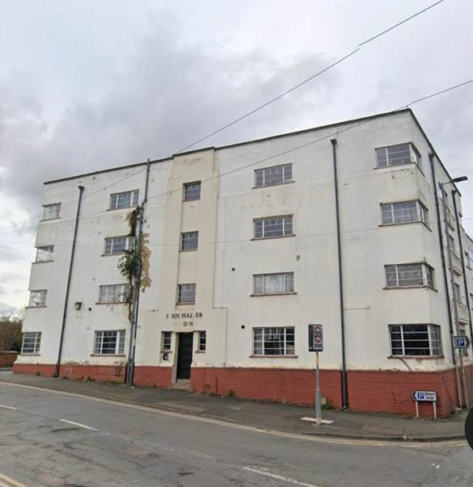
The Council has a statutory duty to address homelessness, supply suitable accommodation of vulnerable residents across Herefordshire. Demand for temporary accommodation has increased steadily, with the number of households accommodated rising from 93 in January 2023 to 184 in January 2026. The costs of providing emergency accommodation continue to rise, with a single room in a local hotel costing the council around £85 per night, equivalent to more than £31,000 per year, while housing benefit payments do not fully cover these costs.

Picture left; John Venn building purchased by the council to place homeless people rather than expensive local hotels.

Recently the Council approved a 4.1 million capital funding programme to improve experience and save money. A key element of the new programme is the introduction of an Empty Properties Grant Scheme to bring long-term vacant homes back into use. Herefordshire currently has more than 1,800 empty properties, including over 600 homes that have been vacant for more than a year. Grants of up to £50,000 per property will be available to support refurbishment, with funding tied to agreements that make homes available at below-market rents. This will enable the council to move families out of temporary accommodation and into more stable housing. The funding will also support the development of accommodation for groups whose housing needs are particularly difficult to meet, including large families, disabled residents and households requiring accessible homes.

The programme also provides transitional accommodation for homeless young people and care leavers, helping them move towards independent living. The council intends to purchase at least four properties for this purpose, creating a stepping stone between supported accommodation and permanent housing. Supported housing placements for looked-after children cost the council on average £61,000 per year. Investment in transitional accommodation has the potential to improve independence while delivering significant long-term savings.

HIGHWAYS

While there are still highways that need investment with over 2,000 miles of highways in Herefordshire, I think it is important to understand that the degree of investment into our highways over recent years is a choice of the current political administration in office at the council, largely paid by borrowing capital with the revenue account paying the interest and capital over a substantial period. If we relied on central government funding we could not do the programme we have and are doing.

Our Local Community Police Team
Sign up to police alerts, you can choose which areas you want to hear about and what activity is taking place in that area. You'll also hear about positive police action, good news stories and be able to play an active part in helping us with our public appeals.
https://link.edgepilot.com/s/bb21d405/UARq0VNajkqv1vLf0zKSJQ?u=http://www.neighbourhoodmatters.co.uk/
Team contact details
Team email: herefordsouthside.snt@westmercia.police.uk
Safer Neighbourhood Officer: PC 21260 Martin Gillett Mobile: 07970 544262
Safer Neighbourhood Officer: PC 21946 Jack Davies Mobile: 07817 158224
Safer Neighbourhood Officer: PC 2347 Lyn Johnson Mobile: 07773 048377
Safer Neighbourhood Officer: PC 22088 Dan Ovel Mobile: 07929 721340
Safer Neighbourhood Officer: PC 21198 Brian Gosson Mobile: 07973 846336
Police Community Support Officer: PCSO 6324 Carol Marsh Mobile: 07890 524667
Police Community Support Officer: PCSO 40259 Hayley Warne Mobile: 07773 052560
Police Community Support Officer: PCSO 40272 Lewis Thomas Mobile: 07773 051508
We are happy to receive calls from Members of The Public, however, please do not use these to report crimes and/or incidents. For more information on reporting a crime/incident please go to www.westmercia.police.uk and select ‘Report’ or call 999 (Emergency) / 101 (Non-Emergency)

Report a crime Police 101 Ext 61216

HIGHWAYS
PLEASE Report potholes and concerns Al
Report problems on the road –
www.herefordshire.gov.uk/roads-1/report-problems-road
Check on progress of a defect
24/7 Phone number:herefordshire.gov.uk/roads-1/pothole-road-defect-progress-map
Report a serious pothole, flooded road or highway obstruction-: 01432 261800
Making a claim for vehicle damage : www.herefordshire.gov.uk/roads-1/highway-claims
Footpaths issues –
• PROW - PROW@herefordshire.gov.uk
• PROW No – 01432 383 550

Report fly tipping it will be dealt with in a much quicker time frame. by either calling the Contact Centre on 01432 261800 or by logging the fly tipping via the council website on the links below as your www.herefordshire.gov.uk/info/fly_tipping

Road Closures / Restrictions

Ballingham C1267 FROM C1266 TO ROCK FARM
HEREFORDSHIRE COUNCIL Highway repair and maintenance works
Road closure FL23002563855-02 Granted 06-Aug '26 06-Aug '26

Carey U72001 BROADWAY LANDS
HEREFORDSHIRE COUNCIL Highway repair and maintenance works
Road closure FL23001959617-02 Granted 06-Aug '26 06-Aug '26

Dinedor C1261 FROM UPPER BOWL COTTAGE TO REDBROOK
OPENREACH Utility asset works
Road closure BC008WG8W523F04SB-04 Granted 03-Aug '26 05-Aug '26

Dinedor U72011 THE CAMP ROAD
HEREFORDSHIRE COUNCIL Highway repair and maintenance works
Road closure FL22011902251-02 Granted 03-Aug '26 04-Aug '26

Dinedor U72009 HOLLOW FARM ROAD
OPENREACH Utility repair and maintenance works
Road closure BC518MAPBWWGNHJF1P-01 Granted 09-Sep '26 09-Sep '26

Green Crize U72015 LOWER BULLINGHAM LANE
OPENREACH Utility asset works
Road closure BC008WG8W533S03SB-05 Granted 27-Jul '26 31-Jul '26

Green Crize C1261 THE PASTURES TO GATEHOUSE ROAD
OPENREACH Utility asset works
Road closure BC008WG8W533SSB-04 Granted 27-Jul '26 31-Jul '26

Hoarwithy U71000 TRESSECK MILL ROAD
OPENREACH Utility asset works
Road closure BC008PLT0036884229032026-02 Granted 23-Sep '26 23-Sep '26

Holme Lacy B4399 FROM DINEDOR MILL BRIDGE TO B4224
HEREFORDSHIRE COUNCIL Highway repair and maintenance works
Road closure FL22094728425-02 Submitted 24-Aug '26 24-Aug '26

Holme Lacy C1266 FROM B4339 TO SNOWDELL COTTAGE
HEREFORDSHIRE COUNCIL Highway repair and maintenance works
Road closure FL23076104001-01 Submitted 30-Jul '26 30-Jul '26

Holme Lacy C1266 FROM B4339 TO SNOWDELL COTTAGE
HEREFORDSHIRE COUNCIL Highway repair and maintenance works
Road closure FL23036905312-02 Granted 06-Aug '26 06-Aug '26

Little Dewchurch C1261 BOGMARSH LANE TO KNAPP GREEN
HEREFORDSHIRE COUNCIL Highway improvement works
Road closure FL23005629838-01 Granted 21-Aug '26 21-Aug '26

Little Dewchurch C1261 BOGMARSH LANE TO KNAPP GREEN
HEREFORDSHIRE COUNCIL Highway repair and maintenance works
Road closure FL23098564481-02 Granted 07-Aug '26 07-Aug '26

Little Dewchurch U72001 BROADWAY LANDS
HEREFORDSHIRE COUNCIL Highway repair and maintenance works
Road closure FL23074960892-02 Granted 06-Aug '26 06-Aug '26
Little Dewchurch C1261 BOGMARSH LANE TO KNAPP GREEN
HEREFORDSHIRE COUNCIL Highway improvement works
Road closure FL012PU2083-05 Granted 01-Aug '26 02-Aug '26

Little Dewchurch U72002 KNAPP GREEN
OPENREACH Utility asset works
Road closure BC008PLT0036894129032026-01 Granted 24-Aug '26 24-Aug '26

Lower Bullingham U72015 LOWER BULLINGHAM LANE
OPENREACH Utility asset works
Road closure BC008WG8W533S04SB-04 Granted 27-Jul '26 31-Jul '26

Ridgehill C1261 GATEHOUSE ROAD TO REDBROOK
OPENREACH Utility asset works
Road closure BC008WG8W523F03SB-04 Granted 03-Aug '26 05-Aug '26

Ridgehill U71616 TWYFORD COMMON ROAD FROM THE OAKS TO CHAPEL HOUSE
OPENREACH Utility asset works
Road closure BC008WG8W523F01SB-06 Granted 06-Aug '26 13-Aug '26

Ridgehill U72014 NORTON BROOK ROAD
OPENREACH Utility asset works
Road closure BC008WG8W523FSB-06 Granted 14-Aug '26 17-Aug '26

Ridgehill C1261 GATEHOUSE ROAD TO REDBROOK
OPENREACH Utility asset works
Road closure BC008WG8W533S01SB-04 Granted 27-Jul '26 31-Jul '26

Parish Contacts

Ballingham, Bolstone & Hentland PC clerk@ballinghambolstonehentland-pc.gov.uk

Dinedor PC clerk@dinedorparishcouncil.gov.uk

Holme Lacy PC holmelacyparishclerk@gmail.com

Little Dewchurch PC parish.clerk@littledewchurch.org.uk

Lower Bullingham PC clerk@lowerbullinghamparishcouncil.co.uk

If you want to discuss a planning matter, please contact
planningenquiries@herefordshire.gov.uk

Planning enforcement concern
PlanningEnforcement@herefordshire.gov.uk

Local Emergency Numbers

Environment Agency: 0800 80 70 60 (24-hours) or visit www.gov.uk/report-an-environmental-incident
Flood alerts: Floodline 0345 988 1188. Sign up online at www.gov.uk/sign-up-for-flood-warnings to get Flood Warnings from the Environment Agency by phone, email or text message. If you live by a river or stream, keep a watch on current and expected water levels.

Power cut: Call 105 or visit www.powercut105.com
BT phone line issues: www.downdetector.co.uk/status/bt-british-telecom
Gas leak: 0800 111 999 or visit www.wwutilities.co.uk/services/smell-gas

Welsh Water: 0800 052 0130 (Water emergencies) or 0800 085 3968 (Sewer emergencies) or visit www.contact.dwrcymru.com/

The Citizens Advice Bureau Online at advice@citizensadviceherefordshire.org.uk for initial contact by email. Please also give a contact phone number in case we need to contact you for
more information.

